**How to Enable Live Server on Visual Studio Code?**

Last Updated : 14 Dec, 2022

Generally, when we make any change in our code, to see those changes on the browser we need to manually refresh the page to see the changes happening. Here the live server extension comes into the picture. After it has been installed, an automated localhost will be able to run in your browser, which you can start with a single button. Once you make changes in your code or write something new, after saving it, the browser will auto-refresh itself, then you will be able to see the changes quickly and automatically. The live server enables you to open an HTML document, and it runs a server for you and opens a browser window with the file in it.

**Steps for Installing and Enabling Live Server on Visual Studio Code**

**Step 1:** Click on the extensions option available on the left side in Visual Studio Code.

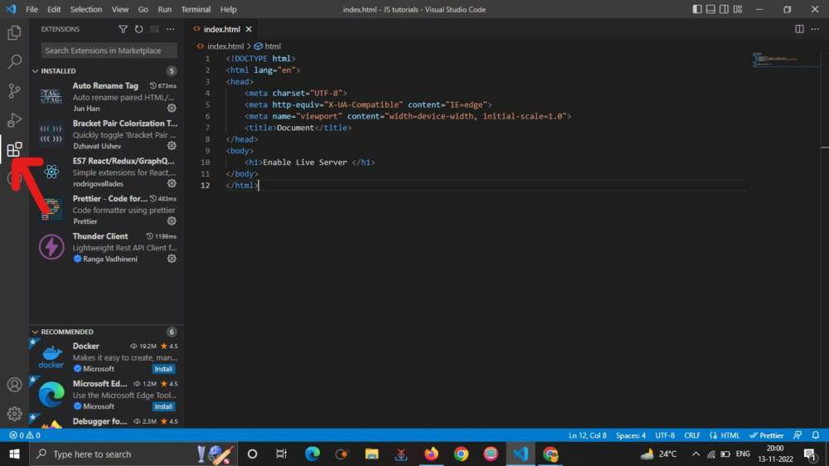

**Step 2:** Search Live Server in the search box and install it.

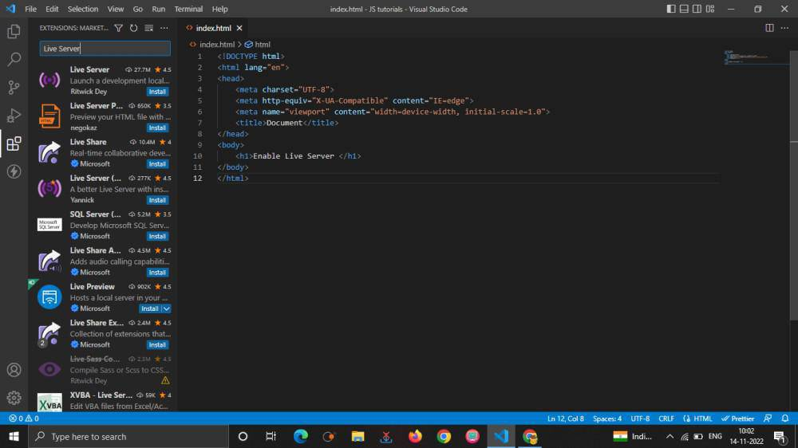

**Step 3:** The live server extension has been installed.

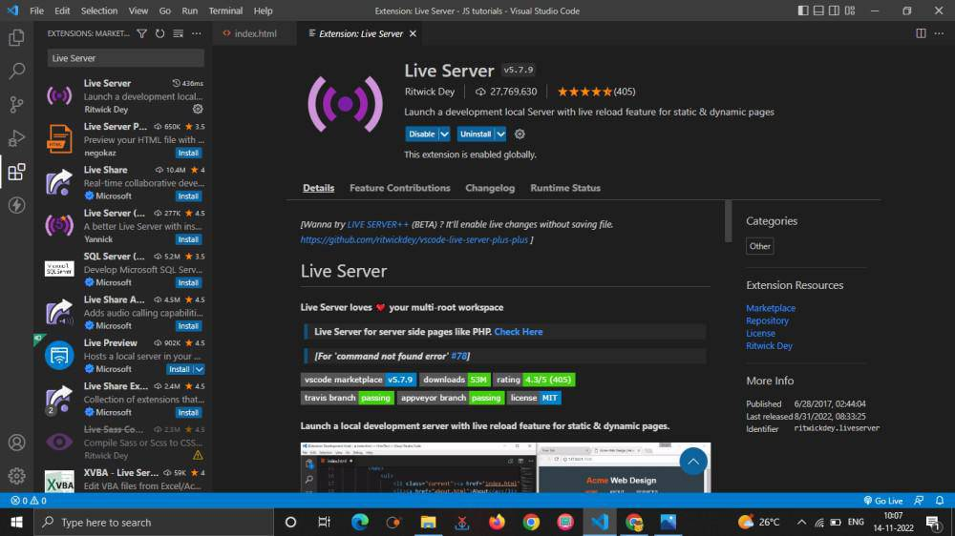

**Step 4:** Click on Go live present at the bottom.

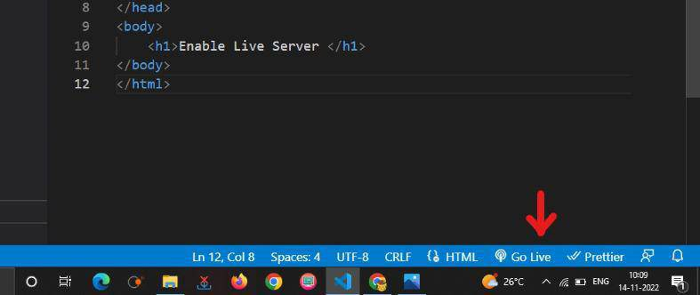

**Step 5:** The default browser will get opened automatically once you click on the go live.

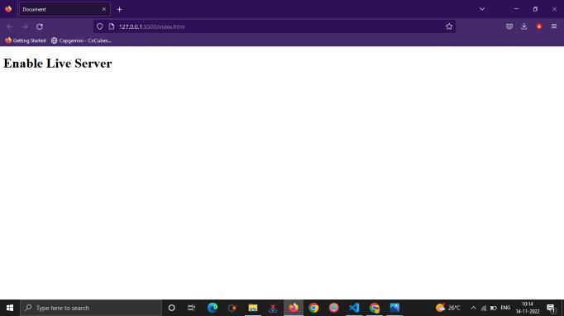

This is how you can turn on the live server mode on Visual Studio Code.

Using npm

Default - npm install live server -g

MacOS - sudo npm install live server -g

Here, npm stands for node package manager and helps us to install various packages.We are requesting npm to install the live server package!

The -g tag implies we are installing it globally (meaning it is available everywhere on our computer).

After installation, run live-server.